1. Magento uses fallback model
2. If not found in default it goes to base theme.
3. Two folders skin folder and app folder

Layouts and blocks :

In app folder remeber ?

Home page is in cms layout options is there

Layout is actual layout like 1 cloumn or 2 etc

Each component is a structural block which could be found in static place of magento.

Widgets dynamically changed blocks.

Fall back model

1. Ur theme will reside in magento/skin/frontend/default/your name
2. If file is not in magento/skin/frontend/default/default also it goes to
3. magento/skin/frontend/base/

Web configuration

Themes :

Skin : blue theme variant only skin will change not template

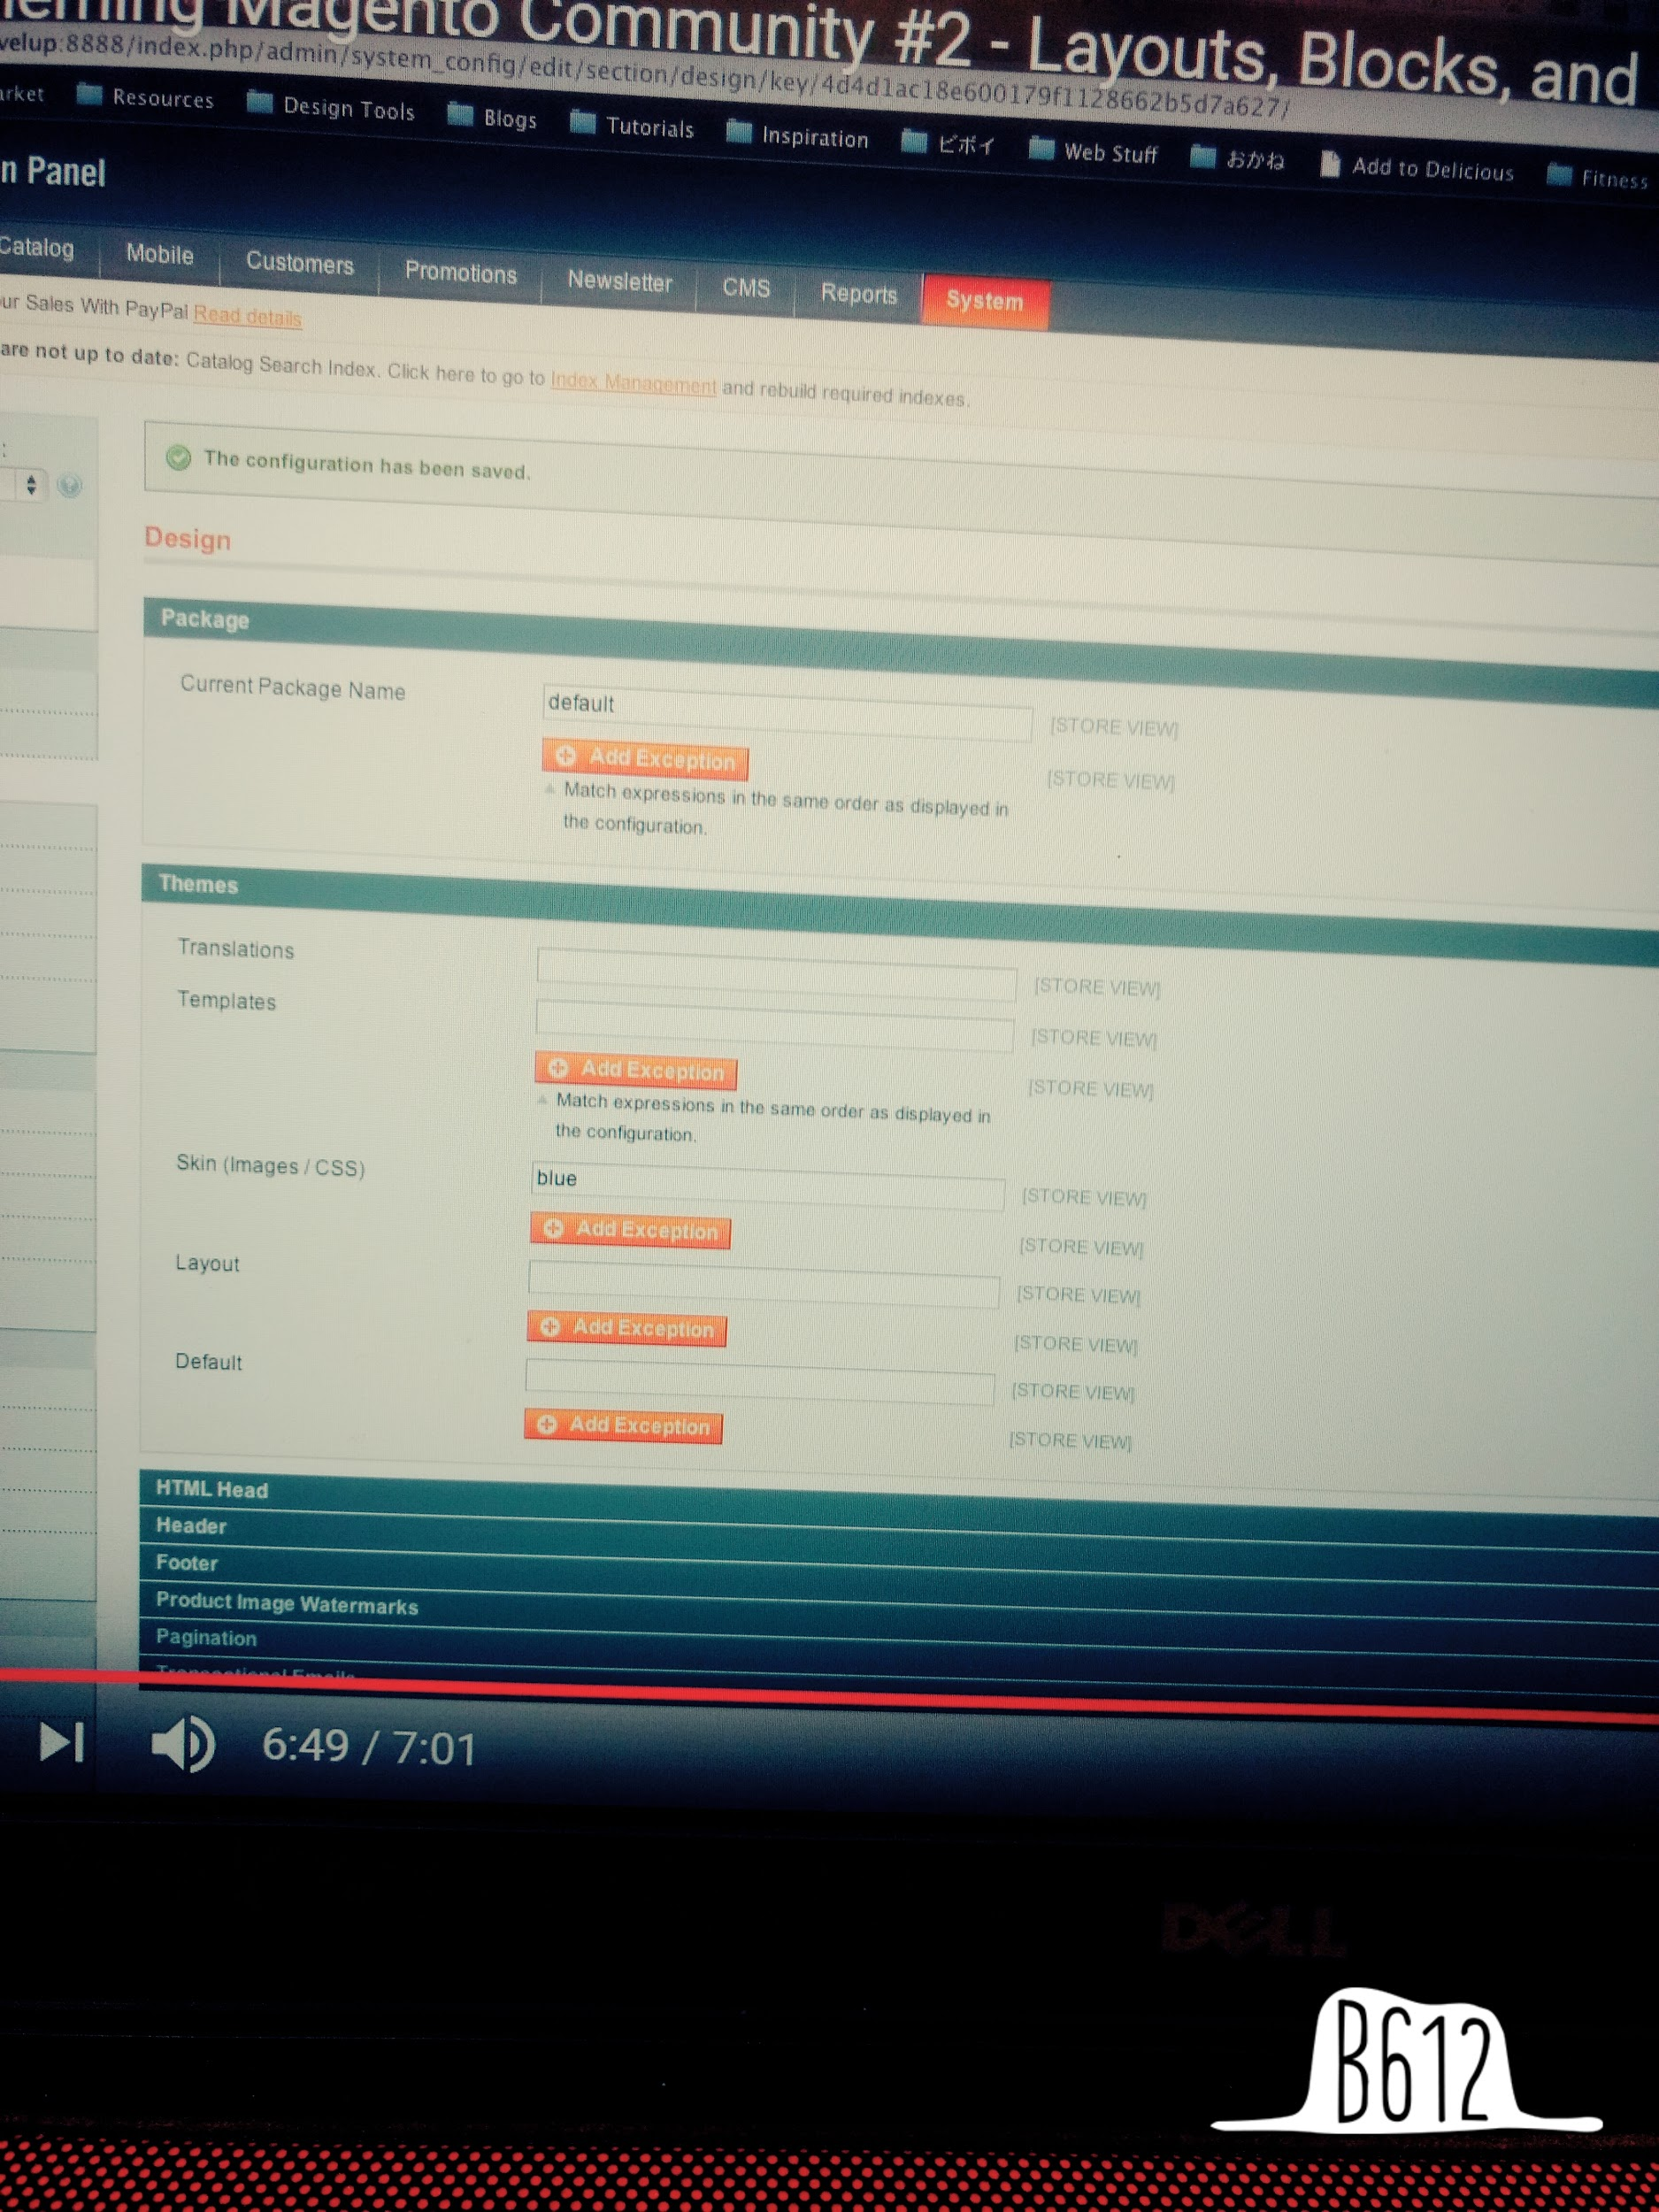

Adding your theme

Skin :

Add in skin/frontend/yourthemefolder

Theme package is skin/frontend/

All folders in this directory are packages

Add skin/frontend/yourthenefolder/default

Now this is your default theme

Add your js +images + css page

App folder

App/design/frontend/yourthemefolder/defualt

Same name aa skin plzz

Add app/design/frontend/yourthemefolder/dedault layout and /template folder

Disable system cache

General - design

Current package : yourthemefolder

Your are done